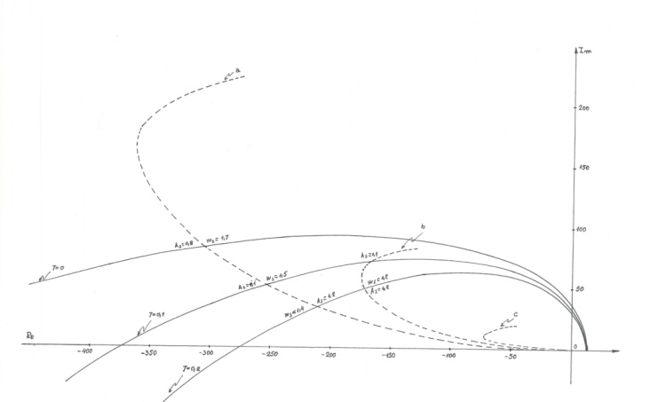

Graphic representation of the intersection of the real and imaginary parts of the characteristic equation